Project Report

|  |  |
| --- | --- |
| Project Title | Problem Manage a Server Outage Scenario & an Issue & Change Request Management System |
| Qualification Name (NICF) | Advanced Certificate in Software Applications (Development and Deployment) |
| Product Name |  |
| Module Name (NICF) |  |

|  |  |  |  |
| --- | --- | --- | --- |
| Student name | | Assessor name | |
| Syukur Sidiq Nur Alam | |  | |
| Date issued | Completion date | | Submitted on |
|  |  | |  |
|  | |  | |
| Project title | Student Registration Form Development | | |

|  |
| --- |
| Learner declaration |
| I certify that the work submitted for this assignment is my own and research sources are fully acknowledged.  Student signature: Date:18 August 2023 |

Table of Contents

1. Project Background 2

2. Project Objective 3

3. Project Requirements Specifications 4

3.1 Functional requirements 4

3.2 Non-functional requirements 4

4. Task 1: Principles of Problem Management 5

4.1 What is Problem Management? 5

4.2 The Three Phases of Problem Management 5

4.3 Principles of Problem Management 5

4.4 Problem Management Example 5

5. Task 2: Tools, Process & Technologies 7

1. Problem Logging 7

6. Task 3: Investigate & Diagnose 8

7. Task 4: Explain Prioritize 8

8. Task 5: Problem Management Solution 9

9. Task 7: Best Practices in Problem Management 10

# Project Background

Developing a Software Developer's Community Portal

ABC Jobs Pte Ltd is embarking on a transformation project to establish a community portal for software developers similar to LinkedIn. This initiative aims to create a hub where programmers and software administrators can seamlessly connect, showcase their skills, explore job opportunities and collaborate in projects. This project aligns with the NICF-Capstone project framework using Java, leveraging knowledge from previous modules including User Interface Framework, Database Design, and Web Development Platform.

The overall goals of the project are twofold:

First, it requires participants to design, plan and rigorously test the community portal developed in Module 5, demonstrating the ability to synthesize skills learned during their course. Surname. Second, the project addresses the recurring downtime of ABC Jobs Pte Ltd's existing community site. By implementing problem management principles and using advanced tools and technologies, the project aims to address these problems and establish a lasting solution. The project strives to improve incident management and enhancement methods through meticulous documentation, adherence to best practices, and nurturing a vibrant community of software developers.

The evolution of this community portal highlights the intersection of technology prowess and real-world problem solving. It provides a tangible platform for software professionals to collaborate and develop, and illustrates participants' ability to translate theoretical knowledge into real-life solutions with lasting impact. to an important industry.

**Scope of the project**

* Explain the principles of problem management.
* Use a variety of tools, processes and techniques to identify problems.
* Conduct investigation, analysis and resolution.
* Explain the steps to investigate and diagnose problems.
* Prioritise and classify change requests.
* Prepare a solution to address the root cause of the problem.
* Document and monitor problems
* Explain best practice for documenting problems.

# Project Objective

The goal of the project is to effectively manage and resolve issues related to the community portal by implementing an issue management framework. This involves identifying, investigating, and resolving issues to improve the stability and performance of the website. The goal is to streamline incident and change request management, prioritize issues, propose solutions, and establish a robust issue documentation process.

**Tools & Platforms Used**

a. **IntelliJ IDEA**

• Purpose: Used as the primary integrated development environment (IDE) for developing Java-based software tools.

• Function: Provides a comprehensive platform for coding, debugging and testing Java programs, ensuring efficient community portal development and maintenance.

b. **Excel Sheet**

• Purpose: Used to track issues and maintain a database of known bugs.

• Function: Enable the team to log and manage issues, monitor their status, and establish an archive of common failures, facilitating effective troubleshooting and resolution.

c. **Microsoft Word**

• Purpose : Used to generate incident management reports.

• Function: Allows the creation of detailed and structured reports documenting the issue management process, including identifying, analyzing, and resolving Community Portal issues.

d. **Diagram.net / draw.io**

• Purpose: Used to create visual diagrams, such as fishbone diagrams, for root cause analysis.

• Function: Allows the creation of clear and organized diagrams that help analyze the root cause of problems. Specifically, fishbone diagrams help identify the underlying factors that contribute to community portal issues.

Utilizing these tools and platforms, the project aims to efficiently develop, manage, and document the problem management process, leading to an improved and more reliable community portal for software developers.

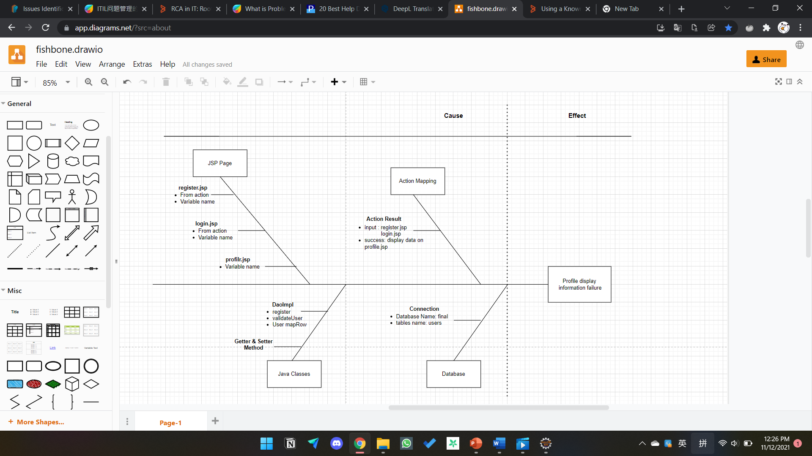

# Project Requirements Specifications

## **3.1 Functional requirements**

## ****3.1 Functional requirements****

**Users (Software Programmer)**

**Register:** New Software Programmers can create an account and register on the community portal.

**Login:** Software Programmers can log in to their accounts using their credentials

**Logout:** Software Programmers can log out of their accounts to end their session.

**Posting Thread: Software Programmers should be able to post on their dashboard**

**Comment on Thread: Software Programmers should be able to comment on threads.**

**Search users:** The Software programmers can search for other users by parameters like First Name, Last Name, City.

**View Other Users: Software Programmers can view other profiles after searching it.**

**Update profile:** Software Programmers can edit and update their profile information.

**Apply Jobs: Software Programmers can apply job that already post by Admin.**

**Administrator**

**Login:** Administrators can access their accounts with their login information.

**Add user:** To end their session, administrators can log out of their accounts.

**Delete user: admin can delete user data that has registered on the portal.**

**Modify user:** The admin can update the data of registered users on the portal.

**Send Bulk Email: The admin can send Bulk Emails to the users in the community portal.**

**Post Jobs: The admin can post the jobs in the community portal.**

## ****3.2 Non-functional requirements****

**Safety Requirements:**

The community portal project has specific safety requirements due to the sensitive nature of user data:

1. **Data Privacy and Security:** The database contains the personal information of users, necessitating robust data privacy and security measures. Ensure compliance with relevant data protection regulations and implement encryption and access controls to safeguard user data from unauthorized access or breaches.
2. **Audit Trails and Logging:** Implement comprehensive audit trails and logging mechanisms to track user interactions and system activities. This helps monitor and investigate potential security breaches or unauthorized access attempts.

**Performance Attributes:**

1. **Availability:** The community portal aims to achieve high availability to ensure uninterrupted user access. Implement load balancing, redundancy, and failover mechanisms to minimize downtime in case of server failures. Regularly conduct disaster recovery drills to ensure swift recovery during unexpected incidents.
2. **Maintainability:** The administrator should regularly monitor and maintain the community portal to ensure optimal performance. Schedule routine maintenance tasks, such as database backups, software updates, and performance optimization, to enhance the portal's stability and longevity.
3. **Usability:** The ABC community portal is designed to accommodate many users and a substantial amount of user information. To ensure usability:
   * **Scalability:** Design the system to handle increased user load and data growth. Implement horizontal scaling by adding more servers or resources as needed.
   * **User-Friendly Interface:** Develop intuitive and user-friendly interfaces that enable users to navigate portals, find information quickly, and perform tasks efficiently.
   * **Responsive Design:** Ensure the portal design is responsive and adaptable to various devices and screen sizes, enhancing the user experience across multiple platforms.
   * **Efficient Search and Retrieval:** Implement efficient search and retrieval mechanisms to enable users to access their desired information quickly, even as the database grows.
   * **Optimized Performance:** Utilize caching mechanisms, minimize database queries, and employ content delivery networks (CDNs) to optimize page load times and overall performance.

By addressing these non-functional requirements, the project ensures the community portal's safety, performance, availability, maintainability, and usability. These requirements contribute to delivering a reliable and user-friendly experience for administrators and users of the ABC community portal.

# Task 1: Principles of Problem Management

## What is Problem Management?

Incident management is a proactive IT service management process that identifies, investigates, analyzes, and resolves the root cause of incidents and incidents. The focus is on addressing the root cause of recurring issues, minimizing their impact on services, and preventing similar incidents in the future.

## 4.2 The Three Phases of Problem Management

1. Problem Identification

This phase signifies the early recognition of potential issues that may affect IT services. This involves leveraging sources such as incident reports, trend analysis and user feedback to proactively identify potential problems and prevent their escalation.

**Incident Reports:** Monitoring and analyzing incident reports helps in identifying recurring patterns or issues that may indicate an underlying problem.

**Trend Analysis:** Examining historical data and trends can reveal anomalies or deviations that can lead to potential problems.

**User Feedback:** Gathering feedback from users can provide insight into their experience, uncovering issues before they become a major concern.

1. Problem Control

Immediate steps are taken at this stage to temporarily reduce the impact of the known problem or prevent its damage. Quick solutions are implemented, such as isolating the problematic component or implementing temporary fixes, until a permanent solution is established.

* **Component Isolation:** If a particular component is causing problems, isolating it can prevent its negative impact from spreading to other parts of the system.
* **Temporary Fix:** Implementing a workaround or workaround can quickly restore functionality while a more permanent resolution is being developed.
* **Service Continuity:** The focus is on maintaining service availability and functionality while minimizing disruption caused by issues.

1. Error Control

* Effective problem management also includes error handling in their workflow. Properly tracking, reporting, and remediating errors that occur during issue management is critical to ensuring process integrity.
* **Error Tracking:** Logging errors and problems encountered during problem management allows for a systematic understanding of where problems may occur in the process.
* **Error Reporting:** Transparently communicating errors to the relevant team ensures that issues are recognized and can be dealt with efficiently.
* **Error Correction:** Correcting errors in a timely manner prevents them from spreading further and maintains the accuracy and reliability of the entire problem management process.

## 4.3 Principles of Problem Management

1. Problem Identification

* **Sources of Identification:** Problem identification can come from user reporting, system monitoring, and analysis of operational data.
* **Initial Categorization:** The identified problems are given an initial category based on their type or impact, assisting in the shifting of treatment priorities.

1. Problem Investigation

* High-priority or high-risk issues should be addressed first as their impact on service is highest. The speed at which issues are investigated and diagnosed depends on the priority assigned. Properly categorizing issues makes it easier to identify trends.
* **Investigation Priority:** Issues with high impact or high risk receive higher priority in the investigation process.
* **Data Analysis:** Incident data and other information is analyzed to identify patterns or trends that can assist in investigations.
* **Source Identification:** The main aim of an investigation is to identify the underlying source of the problem.

1. Problem Analysis

* **RCA (Root Cause Analysis):** Involves an in-depth analysis method to identify the root cause of the problem, not just the surface symptoms.
* **Recovery Measures:** Based on the analysis, more effective and permanent recovery measures are planned.

1. Problem Resolution

* **Solution Development:** The problem team designs a solution that focuses on addressing the root cause of the problem.
* **Change Deployment:** The change is implemented, and the service is returned to its normal state with the new solution being implemented.

1. Review

* **Effectiveness Evaluation:** Evaluation is conducted to ensure that the implemented solution actually addresses the problem.
* **Lessons Learned:** Lessons from this issue are documented to improve the problem management process in the future.

## 4.4 Problem Management Example

Identification problem:

1. User Profile Data Issues:

* Description: Users were unable to view their profile data while logged in.
* Impact: User experience is impaired, potentially affecting service satisfaction.

1. Error Viewing Invalid Credentials:

* Description: An error was not displayed when the user entered incorrect login credentials.
* Impact: The user may not understand why the login attempt failed.

Problem Identification:

1. User Thread Not Showing:

* Description: Users were unable to view Thread Section while logged in.
* Impact: User not satisfied, potentially affecting service satisfaction.

1. Error Viewing Invalid Credentials:

* Description: An error was not displayed when the user entered incorrect login credentials.
* Impact: The user may not understand why the login attempt failed.

Evidence No. 1

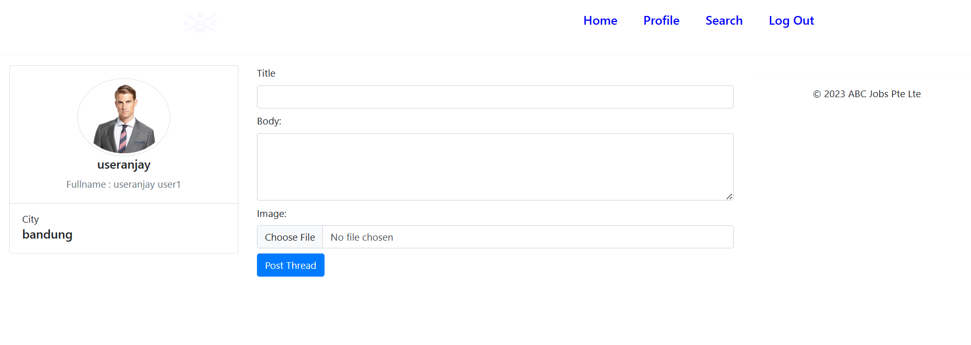

Evidence No. 2

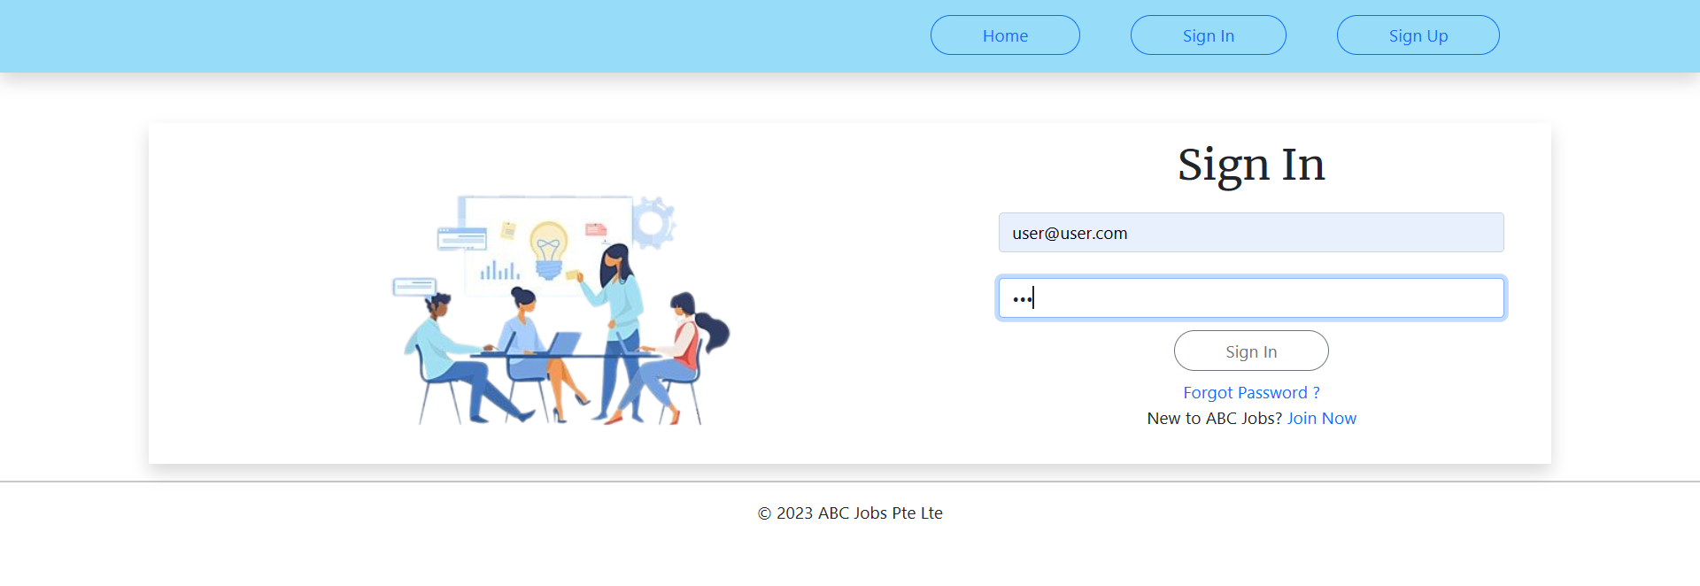

# Task 2: Tools, Process & Technologies

|  |  |  |  |  |  |  |  |  |  |  |
| --- | --- | --- | --- | --- | --- | --- | --- | --- | --- | --- |
| Issue Identification and Tracking Document | | | | | | | | | | |
| Created By: | | | Syukur Sidiq Nur Alam | | Last Update By: | | |  | | |
| Date Created: | | |  | | Last Revision Date: | | |  | | |
| Issue No. | Issue Description | Issue Type | Identified By | Date Identified | Issue Assigned To | Target Resolution Date | Priority | Status | Date Resolved | Resolution Description |
| 1 | Thread Not Showing in the Dashboard | Technical Issues | member | 17-8-2023 | Software Development  Team | 18-8-2023 | High | Resolved | 18-8-2023 | Correcting Items and Var in JSP Page |
| 2 | Invalid login details error not displayed | Technical Issue | Software Tester Team | 10-8-2023 | Software Development  Team | 11-8-2023 | High | Resolved | 11-8-2023 | Adding the code of message |

## Problem Logging

Techniques = Issue Tracking System

Using an Excel sheet to make a tracking document template is an important tool for issue identification.

Process:

Create a Document Template

Start by opening Microsoft Word and creating a template for tracking identified issues. This template will serve as a structured format for recording and monitoring issues.

Design the Issue Tracking Template

Open Figma and design a visually appealing and user-friendly issue tracking template. Incorporate sections for essential details, such as description, issue type, identifier, date of identification, assigned team, target resolution date, priority, current status, date resolved, and resolution description.

Document Each Issue

Fill in the issue details in the Word document using the template you've designed in Figma.

Include a brief description of the issue, categorize its type, note the person who identified it, and specify the date of identification.

Visualize the Template

Enhance the Figma template by incorporating data visualization elements, such as color-coding for different priority levels or a progress bar to indicate issue resolution status.

Update Tracking Document

As issues progress through the resolution process, update the Word document with relevant information. Include assigned teams, target resolution dates, current statuses, and dates of resolution.

Stakeholder Communication

Use the Word document to communicate the status and resolutions of issues to relevant stakeholders. Clearly convey the progress made and any updates.

If needed, export visuals from Figma and insert them into the Word document for a comprehensive overview of issue tracking.

Leverage Tools for Management

Utilize Figma's interactive features to create a clickable prototype of the issue tracking template. This allows stakeholders to navigate and explore issue details directly within the prototype.

1. **Problem Investigation**

Techniques = Root Cause Analysis

Process:

Utilize Fishbone Diagram

Apply the Fishbone Diagram, also known as the Ishikawa or Cause-and-Effect Diagram, as a structured approach to identifying root causes. This method provides a visual framework for comprehensive analysis.

Identify Major Categories

Segment the Fishbone Diagram into major categories that could potentially contribute to the issue. These categories may encompass aspects such as people, process, equipment, environment, and materials.

Drill Down into Each Category

Delve deeper into each category to uncover potential root causes that might be responsible for the observed problem. Explore factors within each category that could have led to the issue's occurrence.

Encourage Cross-Functional Discussions

Facilitate collaborative brainstorming sessions involving diverse team members. Gather insights and perspectives from individuals with varied expertise to uncover a comprehensive range of potential causes.

Prioritize Root Causes

Evaluate and prioritize the identified root causes based on their significance and relevance to the issue. This step aids in determining which causes warrant immediate attention and targeted corrective actions.

Enable Targeted Corrective Actions

With a clear understanding of the root causes, proceed to design and implement focused corrective actions. Address each identified cause with appropriate solutions to effectively resolve the problem.

# Task 3: Investigate & Diagnose

1. Investigate the problem

Issue 1: User Thread Not Showing in the Dashboard

* Issue Description: User thread is not displaying on the dashboard.
* Issue Type: Technical Issues
* Identified By: Customer
* Date Identified: 15-8-2023
* Issue Assigned To: Software Development Team
* Target Resolution Date: 16-8-2023

**Investigation:** To investigate this, the software development team needed to analyze the functionality of the dashboard in relation to viewing the user's feed. They should review relevant code, database queries, and any recent changes to the system. It's essential to understand whether it's a data issue, a code error, or a configuration issue that's preventing the user thread from showing up on the dashboard. .

Issue 2: Invalid Login Details Error Not Displayed

* Issue Description: The invalid login details error message is not displayed.
* Issue Type: Technical Issue
* Identified By: Software Tester Team
* Date Identified: 08-8-2023
* Issue Assigned To: Software Development Team
* Target Resolution Date: 09-8-2023

Investigation:The software development team should review the logging functionality and error handling procedures to investigate this issue. They should review the code responsible for validating the connection information and displaying the error message. The investigation aimed to determine why the system did not display an error message when invalid credentials were provided.

1. Diagnose the problem

Issue 1: User Thread Not Showing in the Dashboard

Diagnosis:

After investigating the issue, we found that a recent code update caused a bug in the code responsible for retrieving and displaying the user string on the dashboard. The error caused the system to skip retrieving the user string from the database, leaving them missing in the console.

Diagnosis Steps:

The development team has defined the specific piece of code responsible for querying and displaying the user string. Through reviewing and debugging the code, they assumed the problem was an incorrect SQL query that failed to retrieve the required data. This results in an empty result set, resulting in no user strings on the console.

Diagnosing the Root Cause of the Problem through Debugging:

Debugging is a crucial step in diagnosing software-related issues. In this case, the development team utilized debugging techniques to uncover the root cause of the problem:

* Code Inspection: Developers reviewed the code responsible for fetching user threads and analyzed the logic behind the data retrieval process.
* Print Statements: The team strategically inserted print statements within the code to track the data flow and identify where the process was breaking.
* Variable Inspection: Debugging tools were used to inspect the values of variables and database queries during runtime to identify discrepancies or errors.
* Step-by-Step Execution: Developers executed the code step by step, monitoring variable values and code behavior at each stage to pinpoint the moment when the data retrieval failed.

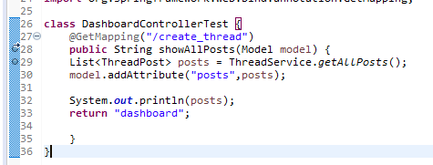

Issue 2: Invalid Login Details Error Not Displayed

Diagnosis: After investigating the issue, it was identified that the error message display code is not being executed when invalid login details are entered. As a result, users need to receive feedback when their login attempts fail.

Diagnosis Steps: The development team traced the issue to an oversight in the login validation process:

* Code Review: The developers reviewed the code responsible for validating login details and identified that the error message display function was not being called within the code block handling invalid login attempts.
* Conditional Logic Issue: Upon further examination, it was discovered that a conditional statement intended to trigger the error message display was not evaluated correctly due to a typo in the code.
* Test Scenarios: The development team executed test scenarios with deliberately incorrect login details to replicate the problem and observe the system's behavior. They confirmed that the error message was not appearing as expected.

Debugging was essential in uncovering the root cause of this issue:

* Code Inspection: Developers reviewed the login validation code and identified the conditional logic governing the error message display.
* Debugging Statements: Print statements were inserted to confirm the flow of execution and identify whether the code block for the error message display was being entered.
* Condition Evaluation: Debugging tools were used to inspect the values of variables and expressions during runtime to pinpoint the moment when the conditional statement failed to evaluate correctly.
* By leveraging debugging techniques, the development team identified the root cause—conditional statement error—and rectified the issue. The error message for invalid login details was reinstated, providing users with the necessary feedback.

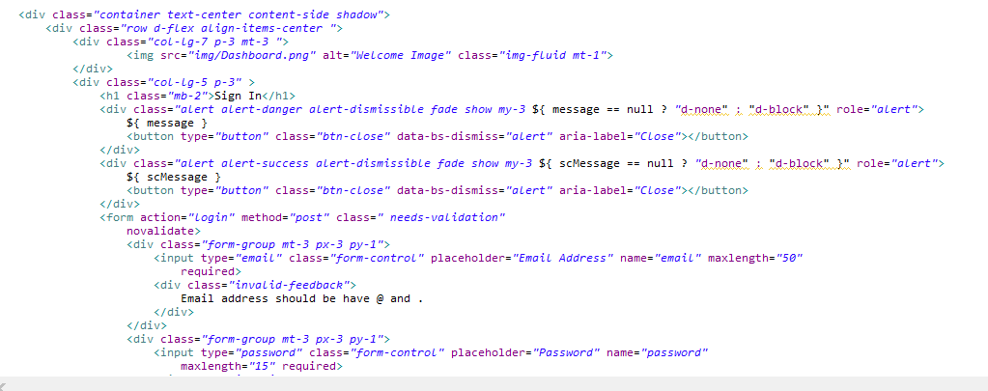

**Task 4: Explain Prioritize**

## Priorities and categories problems:

**Tier 1: Low priority issues**

* The first tier is for basic or minor problems.
* Manage low-priority incidents that don't impact business operations. It is easy to solve and very repetitive. Usually the incidents here are converted into problem patterns.

**Tier 2:** **medium priority issues**

* The second tier is the major problems.
* Resolve issues that affect users but not the entire business. These incidents require more skill or accessibility to deal with.

**Tier 3:** **High Priority Issues**

* The third tier is the critical problem
* Manage incidents that affect the entire organization and multiple users. These incidents are high priority and often enter the Major Incident Response process.

**Problems Categories Diagram:**

| **Tier** | **Priority** | **Description** | **Scope** | **Characteristics** |
| --- | --- | --- | --- | --- |
| 1 | Low | Basic or minor problems that are easy to solve and repetitive. Often converted into problem patterns. | Doesn't impact business operations. | Minor impact, repetitive, easy to solve. |
| 2 | Medium | Major problems that affect users but not the entire business. Requires more skill or accessibility. | Affects users but not entire business. | Moderate impact, requires more skill. |
| 3 | High | Critical problems affecting the entire organization and multiple users. | Affects entire organization and multiple users. | Critical impact, requires immediate action. |

# Task 5: Problem Management Solution

**Solution for Thread not showing in The Dashboard:**

1. Debug create_thread endpoint
2. Check the logic in create_thread endpoint
3. Ensure in the JSP have a correct var and items it will sync with backend and database.
4. Ensure have implement endpoint to call all thread

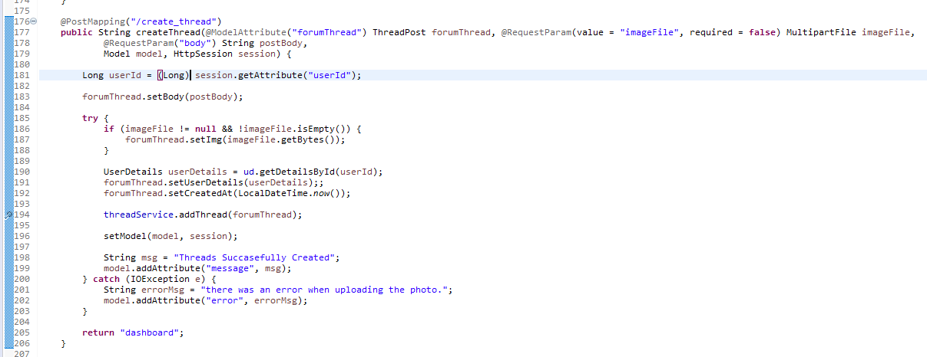

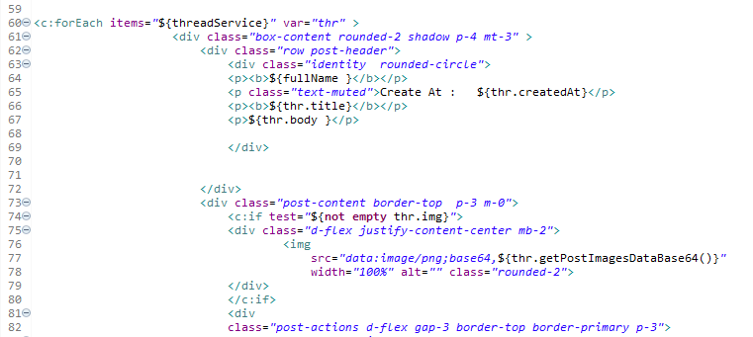

Identify the var and items. And check the attribute in the thread

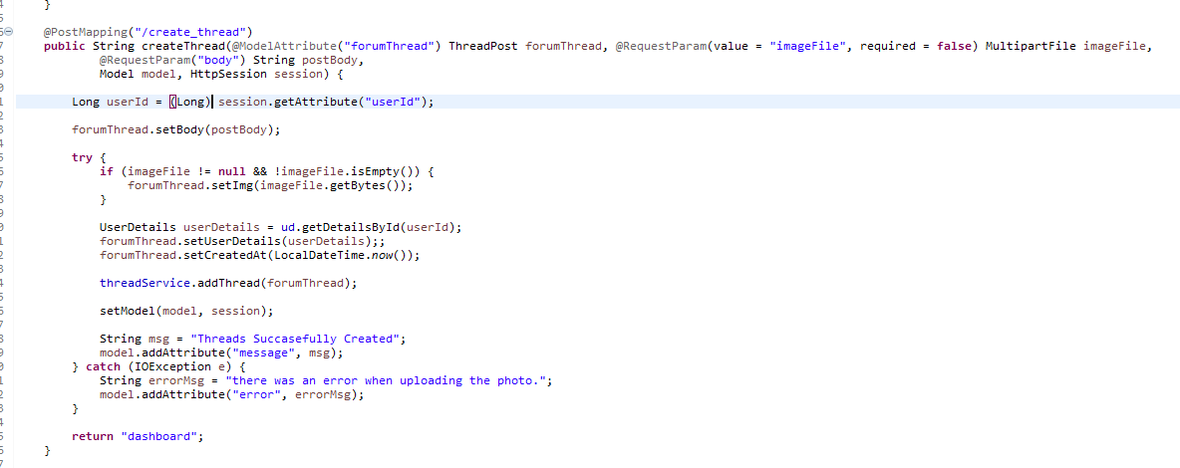

And this is the endpoint for call the thread

**Solution for Invalid login details error not displayed:**

1. Debug Login Endpoint
2. Ensure the data user has saved in database
3. Identify the login.jsp have a correct variable to synchronize with backend
4. Ensure the login.jsp have a code for show the message

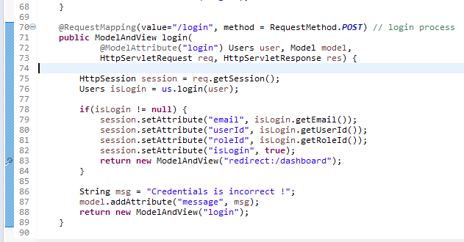

Debug Login Endpoint. Ensure we have a correct logic

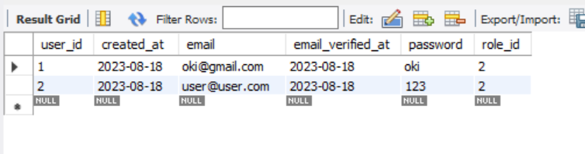

The Data of User already registered has saved to database

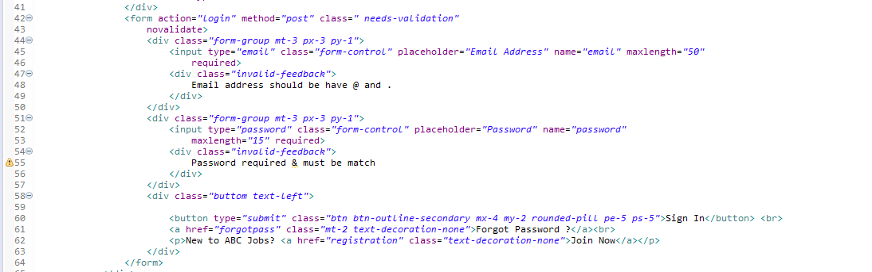

Add the message code if error login

Ensure All the variables is correct

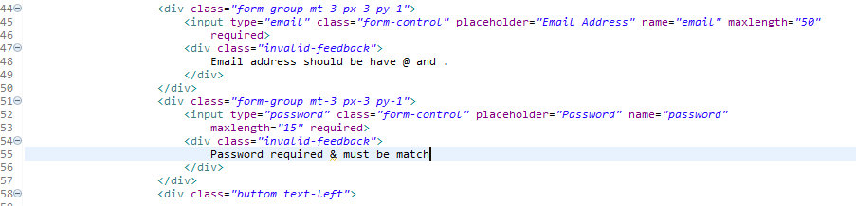

|  |  |  |  |  |  |  |
| --- | --- | --- | --- | --- | --- | --- |
| Known Error Database | | | | | | |
| **Ticket no.** | Issue Description | Issue Type | Root Cause | Workaround | Status | Date Resolve |
| 1. | User Thread Not Showing in the Dashboard | Technical Issues | There is mistake items and var in JSP Page | Correcting Items and Var in JSP Page | Resolved | 16-8-2023 |
| 2 | Invalid login details error not displayed | Technical Issue | Code for Error message is empty | Adding the code of message | Resolved | 09-8-2023 |

# Task 6: Systems will be implemented

Brainstorming Method:

The Creative Fusion Technique will be implemented to catalyze effective problem-solving and idea generation. The Creative Fusion Technique is a dynamic and collaborative strategy designed to harness the collective intelligence of a team, yielding innovative solutions to identified challenges.

Stages of the Creative Fusion Technique:

1. Challenge Definition: Begin by articulating the core challenge or issue that requires resolution. This can span domains such as incident management, system optimization, or user experience enhancement.

2. Ensemble Assembly: Curate a diverse ensemble of individuals, each bringing unique skills, backgrounds, and expertise relevant to the challenge at hand. The convergence of these perspectives enriches the Creative Fusion session.

3. Ideation Surge: Encourage participants to unleash a torrent of ideas and recommendations addressing the challenge. Embrace both pragmatic and imaginative concepts. Foster an inclusive and non-judgmental atmosphere to stimulate uninhibited expression.

4. Quantity Breeds Quality: Prioritize the generation of a copious volume of ideas initially, deferring the evaluation of their viability or excellence. The objective is to foster a spontaneous outpouring of ideas, unburdened by constraints.

5. Constructive Silence: Throughout the Creative Fusion session, abstain from critiquing or appraising ideas. Each contribution is acknowledged and documented without critique.

6. Synergy and Amplification: Motivate participants to amplify and embellish the ideas presented by their peers. This collaborative synergy can yield polished and ingenious solutions through collective ingenuity.

7. Divergent-Convergent Dynamics: Embark on a divergent phase, where a profusion of ideas is generated. Subsequently, transition into a convergent phase, where the team sifts through the list and spotlights the most promising concepts.

8. Idea Immortalization: Capture all the spawned ideas on a whiteboard, flipchart, or digital medium. This meticulous documentation guarantees the preservation of every idea and furnishes a visual panorama of the Creative Fusion outcomes.

Advantages of the Creative Fusion Technique:

• Multi-Faceted Solutions: The Creative Fusion Technique facilitates a spectrum of solutions by assimilating diverse vantage points and backgrounds.

• Frontier of Innovation: The creative prowess invoked by this technique opens the door to pioneering approaches that might have been overlooked initially.

• Team Synchrony: The Creative Fusion Technique nurtures team cohesiveness and camaraderie, cultivating a shared accountability for troubleshooting.

• Immersed Participation: Team members become deeply immersed and invested in the journey of solution discovery, augmenting their dedication to actualizing the selected remedies.

Execution Strategy:

• Regularly orchestrate Creative Fusion sessions as integral components of problem-solving meetings or workshops.

• Establish an environment conducive to unreserved idea sharing.

• Designate a facilitator to steer the Creative Fusion process, ensuring equitable participation.

• Document all ideas systematically to facilitate subsequent assessment and curation of viable resolutions.

# Task 7: Best Practices in Problem Management

Mastering problem management through meticulous adherence to industry standards and best practices is pivotal for upholding operational excellence and delivering unparalleled service. Here are five foundational best practices to expertly navigate problem management:

1. Empower Clear Client-Incident Handler Distinction: A cardinal principle to ensure a transparent and unbiased problem-resolution journey is the unequivocal separation of clients and incident handlers. Establishing a distinct boundary between the client and the individual addressing incidents obviates potential conflicts of interest. This demarcation fosters impartial analysis, seamless communication, and the unprejudiced pursuit of remedies. This bedrock practice establishes trust, offering clients the assurance that their concerns are attended to objectively and adeptly.

2. Cultivate a Robust Known Errors Repository: A robust Known Errors repository stands as a linchpin for well-informed decision-making and relentless refinement. Every vanquished incident should be meticulously chronicled within this repository. This repository metamorphoses into a treasury of historical incidents and their antidotes, evolving into an invaluable resource for future troubleshooting endeavors. The Known Errors repository expedites the resolution of recurring conundrums and bolsters proactive problem management. Patterns and trends gleaned from this repository act as catalysts for preventive strategies and systemic enhancements, curtailing the potential for predicaments to unfold.

3. Unearth Root Causes and Effectuate Remediation: Addressing the surface-level symptoms of a problem is a starting point, yet equal emphasis must be placed on uncovering and extinguishing the root cause. Conducting meticulous root cause analyses unveils the underlying facets that contribute to incidents. Targeting the root cause serves as a bulwark against the resurgence of akin tribulations and sets the stage for enduring solutions. This practice is emblematic of a commitment to service excellence and the propagation of enduring resolutions.

4. Sustain Uninterrupted Communication and Feedback Loop: Proficient problem management pivots on unswerving communication with clients and stakeholders. Uphold an open feedback loop, enlightening clients about incident resolution progress and any prophylactic measures being instituted. This transparent discourse instills faith in your problem-management protocol and conveys to clients that their concerns are treated with utmost gravity. Moreover, client feedback metamorphoses into a fount of insights for refining problem-management strategies and enriching service dispensation.

5. Engage in Periodic Appraisals and Augmentation: Problem management is a dynamic process that mandates constant introspection and augmentation. Routinely scrutinize the efficacy of your problem management practices, poring over metrics like incident resolution duration and client contentment. Leverage these insights to pinpoint arenas primed for enhancement, hone processes, and activate corrective measures as exigencies arise. A culture of perpetual amelioration guarantees that problem management evolves harmoniously, poised to surmount evolving predicaments.

By embracing these best practices, organizations can ascend the echelons of problem-management proficiency, heighten client gratification, and nurture a culture characterized by resilience and proactive predicament-solving prowess.